“Chatbot Survey”

Concerning Haidy ‘s part:

AI components

# What is AI?

AI is the simulation of human intelligence processes by machines especially computers. It enables us understand information hidden in large volumes of unstructured data .Machine learning can be used to process text or images in seconds and annotate them with positive , negative or neutral sentiment .

During searching about AI main structure I found two types of classifications for AI systems which are:

### Type 1:

## Weak AI vs Strong AI:

-**Weak AI** (also known as narrow AI) is an AI system that is designed and trained for a particular task .It is trained and developed to perform this task and can not do unfamiliar tasks to it which has no previous training experience with it.

Here is an important formula established for weak AI system(The dominant AI system till now) which describe the main components of weak AI systems .

-**Strong AI** (also known as Artificial general intelligence) is AI system which has it ‘s own conscious it has the ability to find solution without human intervention when it is exposed to unfamiliar task . It can make a decision , self awareness and learn from itself . ( NOT PRACTICAL YET)

### Type 2:

It is classified based on functionalities into:

1.Reactive machines:

It doesn’t have past memory and can not use past information for future actions

2.Limited memory:

Can use past experience to inform future decisions

3.Theory of mind:

This type has the ability to understand people emotions, belief , thoughts expectations and able to interact socially “NOT PRACTICAL YET”

4. Self Awareness:

It has it ‘s own conscious ,super intelligent ,self awareness & sentient “NOT PRACTICAL YET”

These types have common components which may all exist in one system or some of them which are as follows:

Talking about each component briefly:

Machine Learning(ML):

(will be discussed later in details)

Natural Language Processing(NLP):

(will be discussed later in details)

Vision:

It can be said as the machine eyes, machine vision captures and analyses visual information using a camera , analog to digital conversion and digital signal processing

Robotics:

Field of engineering focused on the design and manufacturing of robots

Expert Systems

An expert system is a software which use knowledge stored in a knowledge base to solve problems that usually require a human expert knowledge.

-The knowledge base contains files in a particular domain and rules to solve a problem procedure and all the intrinsic data relevant to that particular domain

-Inference Engine role is to inferences data from the knowledge base , rules and apply it to the problem or request of the user to return the required answer

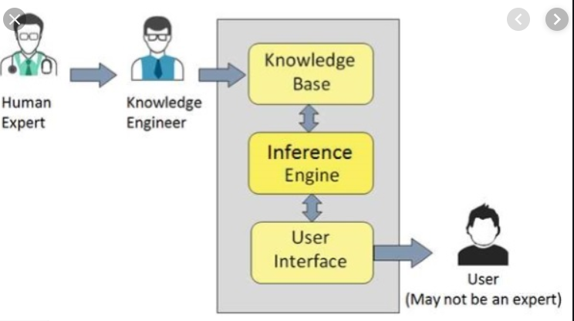

Speech:

(will be discussed later in details)

-By Simple Architecture we can say that AI main components are:

#### The previous explanation was close enough to describing the elements composing most of AI system around and it feeds up the concept of simulating human intelligence but we have a different approach for describing our AI system which is illustrated in the fig. below

-This was the general conclusion concerning what are the AI elements or in other words what is the involved technologies and methods in AI. Here is the answer *Machine learning is a branch of artificial intelligence where a class of data-driven algorithms enables software applications to become highly accurate in predicting outcomes without any need for explicit programming.* Data science, on the other hand, employs computer science disciplines like mathematics and statistics and incorporates techniques like data mining, cluster analysis, visualization. So both of ML and DATA SCIENCE do all the required analysis and involve all the required functionalities required by the system . Important to note that Machine learning is a subset of artificial intelligence. While data science is an interdisciplinary field to extract knowledge or insights from data .

MACHINE LEARNING ALGORITHMS

# WHAT IS ML?

**“A computer program is said to learn from experience E with respect to some task T and some performance measure P , if it ‘s performance on T as measured by P improves with experience E”**

**-TOM Michell**

Since 1950s , machine learning have revolutioned several fields in the last few decades . neural networks is a subset of ML and deep learning is a sub field of neural network .Deep learning has been showing outstanding success in almost most of the applications domain

Machine learning enables human to program computers so that the machines can recognize patterns or learn from what it is being input to it

Machine learning involves three major types of learning and each type has it ‘s methods of solving and used algorithms

**1.Supervised learning**

SL decide the problem of classification, when finite groups of somewhat determined objects are distinguished in a potentially infinite aggregate of objects. As a rule, groups are formed by an expert. Furthermore the expert can explain or not the reasons of the initial classification.

**2.Unsupervised learning**

UL techniques solve the problem of clustering, when the range of initially undetermined objects is split into groups by means of automatic procedure based on the properties of these objects. Whereas the number of groups (clusters) may be given in advance or generated automatically.

**3.Reinforcement learning**

Reinforcement Learning is a learning technique for use in unknown environments. we do not have a straight forward loss function, thus making learning harder compared to traditional supervised approaches.(Simply we can say that our machine learns through a trial and error approach)

-To solve a problem using machine learning you have to go through a certain flow to achieve the output you want, first you have to analyze data and find patterns and then make predictions through equations and formulas and learn from feedback this is the cycle of machine learning process that you have to go through it.

-There are many algorithms used in machine learning as illustrated in the above fig the algorithms based on classification and regression is used in supervised learning while those based on clustering and association is used in Unsupervised learning .

- Here are some algorithms concept :

### Linear regression

It is used for estimating relationships among variables . An independent variable and dependent variable where the dependent variable must be a continuous value .the relation between the independent and dependent variables is linear that is why it is called linear regression So we draw a regression line to give minimum error in predicting the values of these independent variables .

Linear regression formula is :

Y =bo+b1x+e

Where bo : is Y intercept,

b1:slope,

x:independent variable,

e:Error.

### 

### Logistic regression

It is a method used to predict a dependent variable given a set of independent variable such that the dependent variable must be a categorical (ex: have a binary value 0 or 1 ,Yes or No etc.. ). We always use a sigmoid function to map the relation between dependent and independent variables.

Logistic regression formula:

[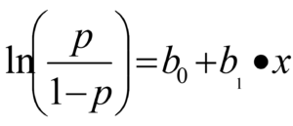](https://www.data-mania.com/blog/wp-content/uploads/2017/05/logistic-regression-example-in-python.png)

Where P:probability of an event to happen

bo: numeric constant,

b1:coeffient of the independent variable

x: independent variable

## K Nearest neighbor

The algorithm is based on calculation of the number of objects in each class of the sphere (hypersphere) with the center in the recognized object. The object belongs to the class, which objects dominate in this sphere. This technique supposes that weights have been chosen individually for every object .If weights are not same, instead of calculation of the number of objects their weights can be added together

## Neural Network

(will be discussed in Mona ‘s part in details)

## Naïve Bayes

It is based on conditional probability and it is particularly suited when the complexity of the inputs is high (ex: Spam mails)

### SVM

given labeled training data (supervised learning), the algorithm outputs an optimal hyperplane which categorizes new examples. In two dimension space this hyperplane is a line dividing a plane in two parts where in each class lay in either side.

Recurrent Neural Networks

# Why RNN ?

In the case where you had to memorize previous information traditional neural network approaches including CNN and DNN can not deal with this due to the following reasons. first, because these approaches only handle fixed size vector as an input and produce a fixed size vector as an output . second , because those models operate with a fixed number of computational steps (number of layers).so we had to find a new approach to deal with such problem which is RNN.

# What is RNN?

RNN is the network with the loops. Which allow information to persist in network. RNN has feedback connection the network itself which allow activations to flow back in a loop , learn sequences and information to persist. RNN can be thought of as multiple copies of the same network each network passing a message to a successor .

-RNN different architectures especially LSTM and GRU are used in most of the types of deep leaning systems, deep supervised learning , deep semi supervised learning , deep unsupervised learning. While standard NN only used in the deep supervised learning only .

-The main problem with the RNN approach is the vanishing gradient problem. Until the arouse of LSTM approach which is then developed into many algorithms whose idea is based on having a memory cell to carry certain information and parse them through the layers .

### Long short term memory (LSTM)

The key idea of LSTMs is the cell state. LSTMs remove or add information to the cell state called gates: An input gate (i), forget gate (f) and output gate (o) the equations can be defined as:

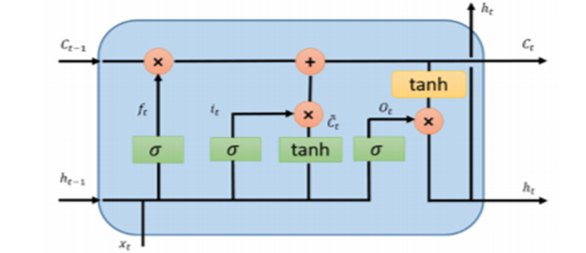

f = σ(W.[h, x] + b),

i = σ(W.[h, x] + b),

C~ = tanh(W.[h, x] + b),

C = f ∗ C + i ∗ C~,

O = σ(W.[h, x] + b),

h = O ∗ tanh(C).

### Gated Recurrent Neural Network

GRU also came from LSTMs with slightly more variations. The main reason for the popularity is the computation cost and simplicity of the model. This technique combines the forget and input gates into a single update gate and merges the cell state and hidden state along with some other changes.

z = σ(W.[h, x]),

r = σ(W.[h, x]),

h~ = tanh(W.[r ∗ h, x]),

h = (1 − z) ∗ h + z ∗ h~

### convolutional LSTM

convolutional LSTM+FCN combines the property of LSTM to preserve or memorize certain information and the ability of CNN to recognize frames and videos, to be able to predict next frames in the video . so instead of having convolutional network that may do sampling in a single step you also have LSTM units that allow information to propagate through the next step .

## According to Application point of view we can classify the RNN applications into many types which are:

1. **One to One**: Standard mode for classification without RNN (e.g., image classification problem)
2. **Many to One**: Sequence of inputs and a single output (e.g., the sentiment analysis where inputs are a set of sentences or words and output is a positive or negative expression)
3. **One to Many**: Where a system takes an input and produces a sequence of outputs (Image Captioning problem: Input is a single image and output is a set of words with context)
4. **Many to Many**: Sequences of inputs and outputs (e.g., machine translation: machine takes a sequence of words from English and translates to a sequence of words in French)
5. **Many to Many**: Sequence to sequence learning (e.g., video classification problem in which we take video frames as input and wish to label each frame of the video)

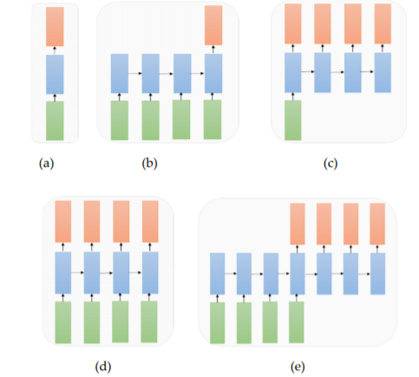

## RNN applications example :

1.Tensor processing

2. Natural language processing

3.Time series data analysis

4.Speech and audio processing

Natural language processing(NLP) &Speech recognition

# NLP

Deep learning and natural language processing (NLP) is an area of computer science and artificial intelligence concerned with the interactions between computers and human (natural) languages. NLP is an automated way to understand and analyze natural human language and extract information from such data by applying machine algorithms.

# NLP and Text mining

Text mining is a vast field that makes use of NLP to derive high quality information from the text , So text mining is the process and NLP is the method to carry out text mining

-- Challenges in natural language processing frequently involve speech recognition, natural language understanding and natural language generation

**Talking briefly about each of them:**

speech recognition

Speech recognition is the problem of understanding what was said. The task of speech recognition is to map an acoustic signal containing a spoken natural language utterance into the corresponding sequence of words intended by the speaker. Given an utterance of text as audio data, the model must produce human readable text

-Particularly a good performance of speech recognition is achieved through the use of speech recognition by the statistical language modelling methods Currently, however the field of natural language processing is shifting from statistical methods to neural network methods. There are still many difficult problems to solve in natural language processing.

Natural language understanding

NLU is the understanding the meaning of what the user or the input which is given means. That is nothing but the understanding of the text given and classifying it into proper intents.

-it is a method for Mapping the given input into a useful representation. Different level of analysis required :

morphological analysis,

syntactic analysis,

semantic analysis,

discourse analysis.

Natural language generation

Producing output in the natural language from some internal representation. Different level of synthesis required:

deep planning (what to say),

syntactic generation

-NLU is harder than NLG due to some ambiguity that NLU has to deal with to understand the natural languages it is dealing with these ambiguities are:

#### Lexical ambiguity

This ambiguity is due to the presence of two or more single meanings within a **single word**

#### Syntactic ambiguity

It is also called structural or grammatical ambiguity , it is due to having **a sequence of words** that may give more than one meaning , which need to be understood by the machine

#### Referential ambiguity

This type arises when we are referring to a certain word using pronouns where the machine sometimes can not understand which word is referred to using this pronoun

# Modelling

Natural language processing is shifting from statistical methods to neural network methods. There are still many difficult problems to solve in natural language processing. Nevertheless, deep learning methods achieve the most modern results for some specific language problems.

Language modelling is really a subtask of more interesting natural language problems, specifically those that condition the language model on some other input. The main problem of language modelling is to predict the next word given the previous words

Language modelling can be useful for various speech and language processing applications, including automatic speech recognition before it used different equations based on conditional probability then now it is using NN approaches specifically RNN

A deep learning language model can predict the probability of the next word in the sequence, based on the words already observed in the sequence. This kind of language modelling is named as word-based language modelling

# NLP Terminology :

## Tokenization

is an essential strategy for most NLP tasks. It parts a sentence or archive into tokens which are words or expressions. For English, it is minor to part words by the spaces

## Normalization

Before further processing, text needs to be normalized. Normalization generally refers to a series of related tasks meant to put all text on a level playing field: converting all text to the same case (upper or lower), removing punctuation, expanding contractions, converting numbers to their word equivalents, and so on. Normalization puts all words on equal footing, and allows processing to proceed uniformly.

Stemming

Stemming is the process of eliminating affixes (suffixed, prefixes, infixes, circumfixes) from a word in order to obtain a word stem.

## Lemmatization

Lemmatization is related to stemming, differing in that lemmatization is able to capture canonical forms based on a word' lemma.

## Parts of speech(POS)

labeling and parsing are strategies that investigate the lexical and syntactic data. POS labeling is utilized to decide the comparing POS tag for each word. Like word division, it is additionally a successive labeling issue. The POS labels, for example, descriptive word, thing, are very useful in light of the fact that opinion words are normally modifiers and opinion targets (i.e., entities and aspects) are things or mix of things. While POS labeling gives lexical data, parsing acquires syntactic data. Parsing produces a tree which speaks to the linguistic structure of a given sentence with the comparing relationship of various constituents. Contrasting with POS labeling, parsing gives wealthier structure data.

# Applications of NLP:

1.Sentimental analysis

2.Chatbot

3.Speech recognition

4.Machine Translation

5.Text categorization

6.Spam filtering

7.Information Extraction

# General conclusions concerning our chatbot:

# Why using RNN in our project?

We are going to use RNN in speech recognition part and NLP due to it ‘s breakthrough in word prediction and text analysis field.

## Useful Links concerning Haidy ‘s task:

AI Components Part

- <https://searchenterpriseai.techtarget.com/definition/AI-Artificial-Intelligence>

- <https://www.researchworld.com/what-are-the-opportunities-and-practical-applications-of-ai-in-research-and-insights/>

- <https://medium.com/@chethankumargn/artificial-intelligence-definition-types-examples-technologies-962ea75c7b9b>

- <https://towardsdatascience.com/role-of-data-science-in-artificial-intelligence-950efedd2579>

NLP

<https://www.researchgate.net/publication/319164243_Natural_Language_Processing_State_of_The_Art_Current_Trends_and_Challenges>